https://virtual-dba.com/blog/error-code-2068-load-data-local-infile-file-request-rejected-due-to-restrictions-on-access/

this link helped in our case.
The Error Code: 2068. LOAD DATA LOCAL INFILE file request rejected due to restrictions on access error occurs when MySQL rejects the LOAD DATA LOCAL INFILE command due to security restrictions. This can happen for various reasons, including server-side and client-side configurations.
Error:
Error Code: 2068. LOAD DATA LOCAL INFILE file request rejected due to restrictions on access.

Steps to Resolve the Error

1. Enable local_infile on the Server
Make sure the MySQL server is configured to allow local file loading by setting the local_infile system variable.

Option 1: Add to Configuration File (my.cnf or my.ini)
[mysqld]
local_infile=1

Option 2: Set Dynamically
SET GLOBAL local_infile = 1;

2. Enable local_infile on the Client

Using MySQL Command Line Client
When starting the MySQL client from the command line, use the –local-infile option:
mysql --local-infile -u your_user -p

Using MySQL Workbench
If local_infile is enabled and still getting errors, you might need to enable opt_local_file.
In the Database dropdown menu, click Manage Connections. Edit the connection: on the Connection tab, go to the ‘Advanced‘ sub-tab, and in the ‘Others:’ box, add the line ‘OPT_LOCAL_INFILE=1‘.
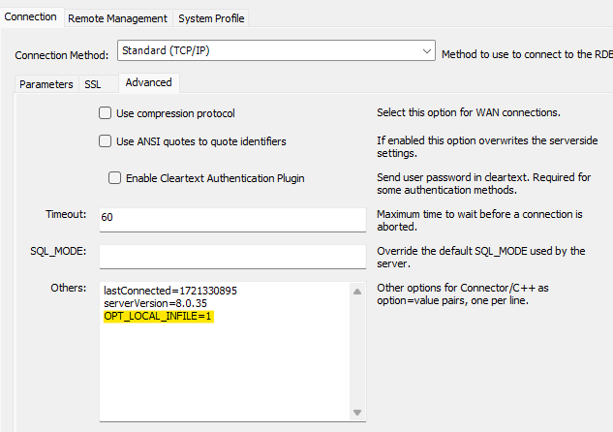

Additional Considerations
- Ensure that the file path is correct and accessible from the client machine.
- Ensure the MySQL user has the necessary permissions to load data into the target table.
- Verify that the file format matches the specifications in your LOAD DATA LOCAL INFILE statement.

Now let's see our problem and execute it.

1. Create Tables
sql
CopyEdit
CREATE DATABASE IF NOT EXISTS shanayabazaar;
USE shanayabazaar;

CREATE TABLE employees (
employeeNumber INT PRIMARY KEY,
lastName VARCHAR(50),
firstName VARCHAR(50),
extension VARCHAR(10),
email VARCHAR(100),
officeCode INT,
reportsTo INT,
jobTitle VARCHAR(50),
FOREIGN KEY (reportsTo) REFERENCES employees(employeeNumber)
);

CREATE TABLE customers (
customerNumber INT PRIMARY KEY,
customerName VARCHAR(100),
contactLastName VARCHAR(50),
contactFirstName VARCHAR(50),
phone VARCHAR(50),
addressLine1 VARCHAR(100),
addressLine2 VARCHAR(100),
city VARCHAR(50),
state VARCHAR(50),
postalCode VARCHAR(15),
country VARCHAR(50),
salesRepEmployeeNumber INT,
creditLimit DECIMAL(10,2),
Rating_of_experience INT,
FOREIGN KEY (salesRepEmployeeNumber) REFERENCES employees(employeeNumber)
);

USE shanayabazaar;

CREATE TABLE orders (
orderNumber INT PRIMARY KEY,
orderDate DATE,
requiredDate DATE,
shippedDate DATE,
status VARCHAR(20),
ratingOfStars INT,
customerNumber INT,
comments TEXT
);

No need of these.
ALTER table orders add COLUMN productCode INT REFERENCES products(productCode) AFTER orderNumber;

ALTER table orders add COLUMN quantity INT AFTER productCode;

select order_details.productCode,products.productName,products.productLine,products.productVendor,order_details.quantityOrdered ,products.buyPrice from products,orders,order_details where products.productCode = order_details.productCode AND order_details.orderNumber=orders.orderNumber;

select order_details.productCode,products.productName,products.productLine,products.productVendor,order_details.quantityOrdered,products.buyPrice from products,orders,order_details where products.productCode = order_details.productCode AND order_details.orderNumber=orders.orderNumber AND customerNumber = 114;

CREATE TABLE products (
productCode VARCHAR(50) PRIMARY KEY,
productName VARCHAR(255),
productLine VARCHAR(100),
productVendor VARCHAR(100),
productDescription TEXT,
quantityInStock INT,
buyPrice DECIMAL(10,2),
MSRP DECIMAL(10,2)
);

CREATE TABLE order_details (
orderNumber INT,
productCode VARCHAR(50),
quantityOrdered INT,
priceEach DECIMAL(10,2),
orderLineNumber INT,
PRIMARY KEY (orderNumber, productCode),
FOREIGN KEY (orderNumber) REFERENCES orders(orderNumber) ON DELETE CASCADE,
FOREIGN KEY (productCode) REFERENCES products(productCode) ON DELETE CASCADE
);

// ALTER TABLE order_details ADD COLUMN totalCost decimal(10,2) DEFAULT (quantityOrdered*priceEach);

// ALTER TABLE order_details ADD COLUMN amountReceived decimal(10,2) DEFAULT 0;

// ALTER TABLE order_details ADD COLUMN amountPending decimal(10,2) DEFAULT (totalCost-amountReceived);

CREATE TABLE payments (
checkNumber VARCHAR(50) PRIMARY KEY,
customerNumber INT,
paymentDate DATE,
amount DECIMAL(10,2),
FOREIGN KEY (customerNumber) REFERENCES customers(customerNumber) ON DELETE CASCADE
);

CREATE TABLE customers (
customerNumber INT PRIMARY KEY,
contactFirstName VARCHAR(50),
contactLastName VARCHAR(50),
phone VARCHAR(20),
addressLine1 VARCHAR(255),
addressLine2 VARCHAR(255),
city VARCHAR(100),
state VARCHAR(50),
postalCode VARCHAR(20),
country VARCHAR(50),
salesRepEmployeeNumber INT,
creditLimit DECIMAL(10,2),
Rating_of_experience INT
);

CREATE TABLE customers_data (
CustomerNumber INT PRIMARY KEY,
Prefix VARCHAR(10),
FirstName VARCHAR(50),
LastName VARCHAR(50),
BirthDate DATE,
MaritalStatus CHAR(1),
Gender CHAR(1),
EmailAddress VARCHAR(100),
Password VARCHAR(50),
AnnualIncome VARCHAR(20),
TotalChildren INT,
EducationLevel VARCHAR(50),
Occupation VARCHAR(50),
HomeOwner CHAR(1),
FOREIGN KEY (CustomerNumber) REFERENCES customers(customerNumber)
);

CREATE TABLE offices (
officeCode INT PRIMARY KEY,
city VARCHAR(100),
phone VARCHAR(20),
addressLine1 VARCHAR(255),
addressLine2 VARCHAR(255),
state VARCHAR(50),
country VARCHAR(50),
postalCode VARCHAR(20),
territory VARCHAR(50)
);

CREATE TABLE product_files ( file_Id INT AUTO_INCREMENT PRIMARY KEY, product_Code VARCHAR(50) NOT NULL, color VARCHAR(50) NOT NULL, file_src TEXT NOT NULL );

LOAD DATA INFILE 'C:/Sudhadocuments/Shanaya_bazaar/classic_models_dataset/product_files.csv'
INTO TABLE product_files
FIELDS TERMINATED BY ','
LINES TERMINATED BY '\n'
IGNORE 1 ROWS
(product_Code, color, file_src);

INSERT INTO customers (customerNumber, customerName, contactLastName, contactFirstName, phone, addressLine1, addressLine2, city, state, postalCode, country, salesRepEmployeeNumber, creditLimit) VALUES
(103, 'Atelier graphique', 'Schmitt', 'Carine', '40.32.2555', '54, rue Royale', NULL, 'Nantes', NULL, '44000', 'France', 1370, 21000.00),
(112, 'Signal Gift Stores', 'King', 'Jean', '7025551838', '8489 Strong St.', NULL, 'Las Vegas', 'NV', '83030', 'USA', 1166, 71800.00),
(114, 'Australian Collectors, Co.', 'Ferguson', 'Peter', '03 9520 4555', '636 St Kilda Road', 'Level 3', 'Melbourne', 'Victoria', '3004', 'Australia', 1611, 117300.00);

INSERT INTO customers_data (customerNumber, customerName, contactLastName, contactFirstName, phone, addressLine1, addressLine2, city, state, postalCode, country, salesRepEmployeeNumber, creditLimit) VALUES
(103, 'Atelier graphique', 'Schmitt', 'Carine', '40.32.2555', '54, rue Royale', NULL, 'Nantes', NULL, '44000', 'France', 1370, 21000.00),
(112, 'Signal Gift Stores', 'King', 'Jean', '7025551838', '8489 Strong St.', NULL, 'Las Vegas', 'NV', '83030', 'USA', 1166, 71800.00),
(114, 'Australian Collectors, Co.', 'Ferguson', 'Peter', '03 9520 4555', '636 St Kilda Road', 'Level 3', 'Melbourne', 'Victoria', '3004', 'Australia', 1611, 117300.00);

INSERT INTO offices (officeCode, city, phone, addressLine1, addressLine2, state, country, postalCode, territory) VALUES
('1', 'San Francisco', '+1 650 219 4782', '100 Market Street', 'Suite 300', 'CA', 'USA', '94080', 'NA'),
('2', 'Boston', '+1 215 837 0825', '1550 Court Place', 'Suite 102', 'MA', 'USA', '02107', 'NA'),
('3', 'NYC', '+1 212 555 3000', '523 East 53rd Street', 'apt. 5A', 'NY', 'USA', '10022', 'NA');

2. Load Data from CSV Files
Ensure that your MySQL server allows loading local files by enabling the local_infile option.
sql
CopyEdit

SET GLOBAL local_infile = 1;

LOAD DATA LOCAL INFILE 'C:/Sudhadocuments/Shanaya_bazaar/classic_models_dataset/employees.csv' INTO TABLE employees FIELDS TERMINATED BY ',' ENCLOSED BY '"' LINES TERMINATED BY '\n' IGNORE 1 ROWS;

LOAD DATA LOCAL INFILE '/C:/Sudhadocuments/Shanaya_bazaar/classic_models_dataset/employees.csv'
INTO TABLE employees
FIELDS TERMINATED BY ','
ENCLOSED BY '"'
LINES TERMINATED BY '\n'
IGNORE 1 ROWS;

LOAD DATA LOCAL INFILE 'C:/Sudhadocuments/Shanaya_bazaar/classic_models_dataset/customers.csv' INTO TABLE customers FIELDS TERMINATED BY ',' ENCLOSED BY '"' LINES TERMINATED BY '\n' IGNORE 1 ROWS;
//when we used this and it starts disturbing the table order from where "" is used in comment. Actually each record in csv is terminated by "" internally but not shown and even if a type is string then also we can't use "" in CSV files.we can use "" in a field if special characters(,) come inbetween.but if other then , nothing else like . - etc can be in ""
146,"Saveley & Henriot, Co.",Saveley,Mary ,78.32.5555,"2, rue du Commerce",NULL,Lyon,NULL,69004,France,1337,123900,1
Here this is completely OK to use "" to show one field overs because it has , in between.

mysql> LOAD DATA LOCAL INFILE 'C:/Sudhadocuments/Shanaya_bazaar/classic_models_dataset/orders.csv' INTO TABLE orders FIELDS TERMINATED BY ',' ENCLOSED BY '"' LINES TERMINATED BY '\n' IGNORE 1 ROWS;
Query OK, 13 rows affected (0.02 sec)
Records: 13 Deleted: 0 Skipped: 0 Warnings: 0

mysql> LOAD DATA LOCAL INFILE 'C:/Sudhadocuments/Shanaya_bazaar/classic_models_dataset/products.csv' INTO TABLE products FIELDS TERMINATED BY ',' ENCLOSED BY '"' LINE
S TERMINATED BY '\n' IGNORE 1 ROWS;
Query OK, 110 rows affected (0.02 sec)
Records: 110 Deleted: 0 Skipped: 0 Warnings: 0

mysql> LOAD DATA LOCAL INFILE 'C:/Sudhadocuments/Shanaya_bazaar/classic_models_dataset/order details.csv' INTO TABLE order_details FIELDS TERMINATED BY ',' ENCLOSED B
Y '"' LINES TERMINATED BY '\n' IGNORE 1 ROWS;
Query OK, 126 rows affected, 2870 warnings (1.00 sec)
Records: 2996 Deleted: 0 Skipped: 2870 Warnings: 2870

mysql> LOAD DATA LOCAL INFILE 'C:/Sudhadocuments/Shanaya_bazaar/classic_models_dataset/payments.csv' INTO TABLE payments FIELDS TERMINATED BY ',' ENCLOSED BY '"' LINES TERMINATED BY '\n' IGNORE 1 ROWS;
Query OK, 273 rows affected (0.03 sec)
Records: 273 Deleted: 0 Skipped: 0 Warnings: 0

mysql> LOAD DATA LOCAL INFILE 'C:/Sudhadocuments/Shanaya_bazaar/classic_models_dataset/Customers_Data.csv' INTO TABLE customers_data FIELDS TERMINATED BY ',' ENCLOSED
BY '"' LINES TERMINATED BY '\n' IGNORE 1 ROWS;
Query OK, 122 rows affected, 125 warnings (0.01 sec)
Records: 122 Deleted: 0 Skipped: 0 Warnings: 125

mysql> LOAD DATA LOCAL INFILE 'C:/Sudhadocuments/Shanaya_bazaar/classic_models_dataset/offices.csv' INTO TABLE offices FIELDS TERMINATED BY ',' ENCLOSED BY '"' LINES
TERMINATED BY '\n' IGNORE 1 ROWS;
Query OK, 7 rows affected (0.02 sec)
Records: 7 Deleted: 0 Skipped: 0 Warnings: 0

Instructions
- Replace /path/to/customers.csv and /path/to/employees.csv with the actual file paths on your MySQL server.
- Run these commands in a MySQL client or MySQL Workbench.
Would you like any modifications or additional constraints?

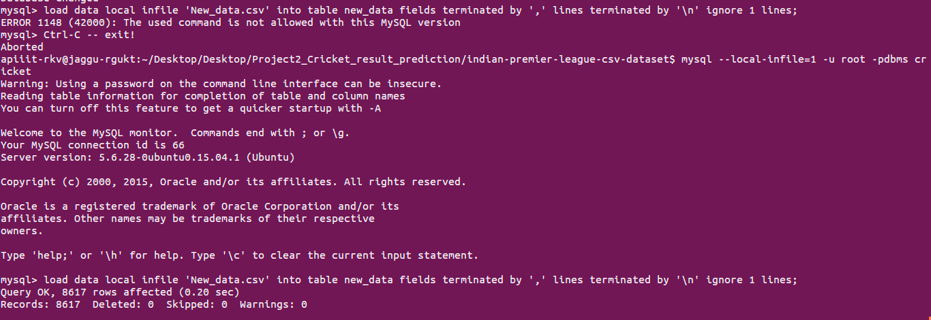

Finally worked in our case

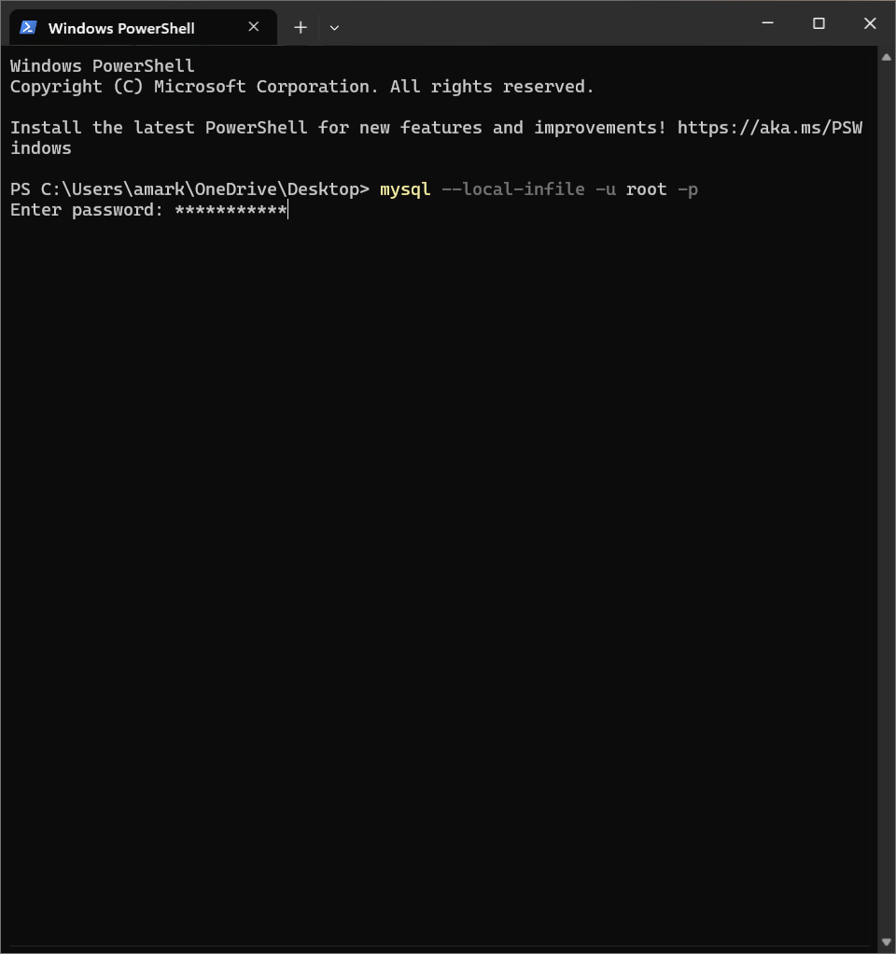
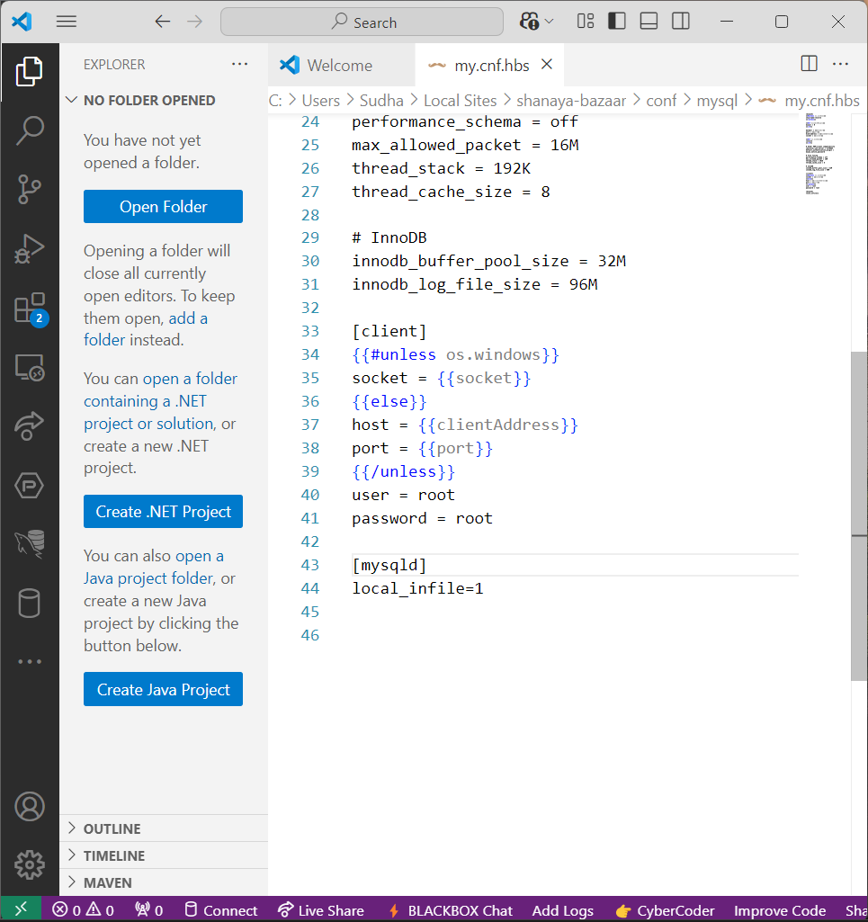

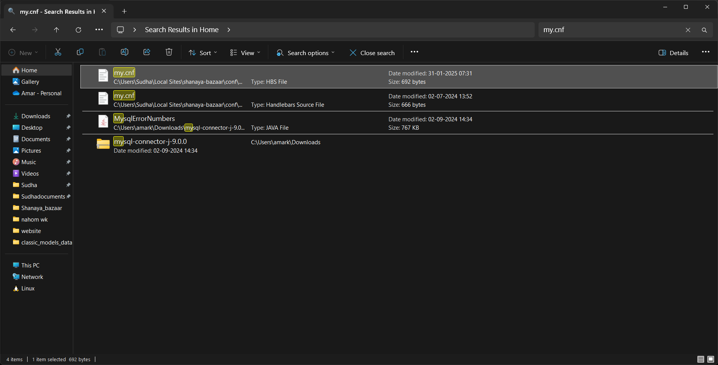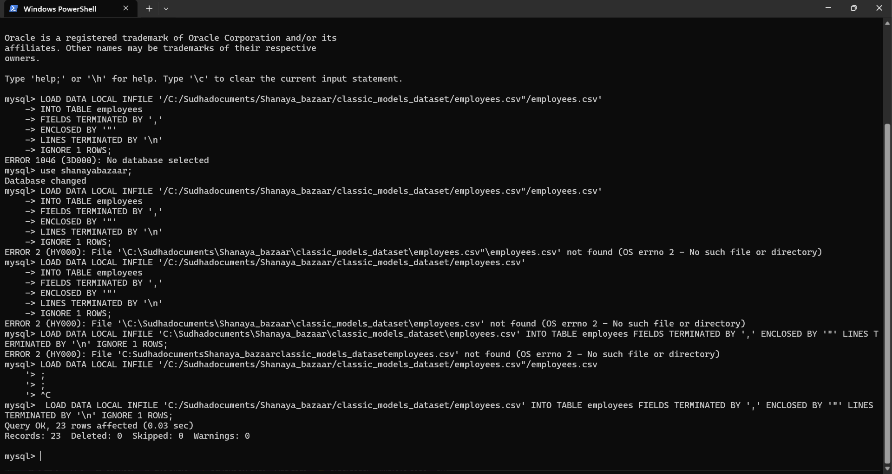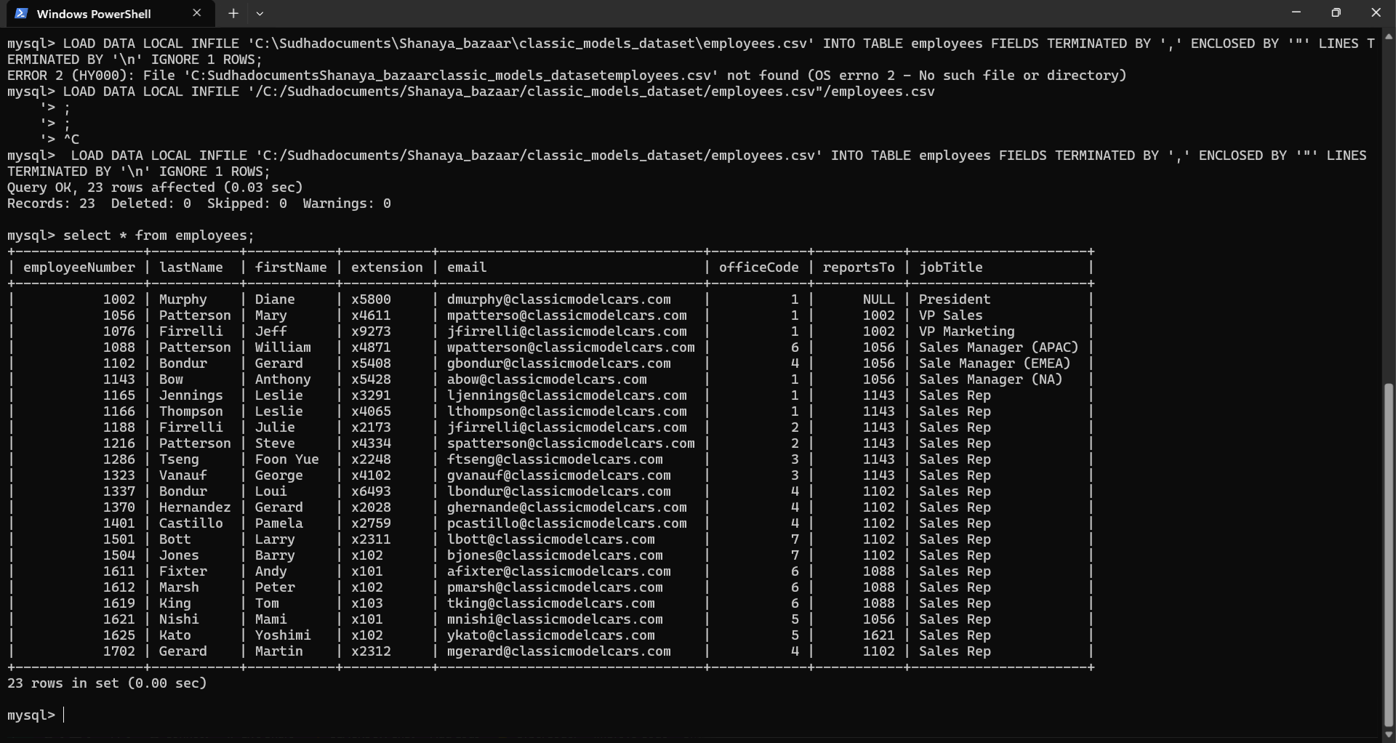

Windows PowerShell
Copyright (C) Microsoft Corporation. All rights reserved.

Install the latest PowerShell for new features and improvements! https://aka.ms/PSWindows

PS C:\Users\amark\OneDrive\Desktop> mysql --local-infile -u root -p
Enter password: ***********
Welcome to the MySQL monitor. Commands end with ; or \g.
Your MySQL connection id is 12
Server version: 8.0.39 MySQL Community Server - GPL

Copyright (c) 2000, 2024, Oracle and/or its affiliates.

Oracle is a registered trademark of Oracle Corporation and/or its
affiliates. Other names may be trademarks of their respective
owners.

Type 'help;' or '\h' for help. Type '\c' to clear the current input statement.

mysql> LOAD DATA LOCAL INFILE '/C:/Sudhadocuments/Shanaya_bazaar/classic_models_dataset/employees.csv"/employees.csv'
-> INTO TABLE employees
-> FIELDS TERMINATED BY ','
-> ENCLOSED BY '"'
-> LINES TERMINATED BY '\n'
-> IGNORE 1 ROWS;
ERROR 1046 (3D000): No database selected
mysql> use shanayabazaar;
Database changed
mysql> LOAD DATA LOCAL INFILE '/C:/Sudhadocuments/Shanaya_bazaar/classic_models_dataset/employees.csv"/employees.csv'
-> INTO TABLE employees
-> FIELDS TERMINATED BY ','
-> ENCLOSED BY '"'
-> LINES TERMINATED BY '\n'
-> IGNORE 1 ROWS;
ERROR 2 (HY000): File '\C:\Sudhadocuments\Shanaya_bazaar\classic_models_dataset\employees.csv"\employees.csv' not found (OS errno 2 - No such file or directory)
mysql> LOAD DATA LOCAL INFILE '/C:/Sudhadocuments/Shanaya_bazaar/classic_models_dataset/employees.csv'
-> INTO TABLE employees
-> FIELDS TERMINATED BY ','
-> ENCLOSED BY '"'
-> LINES TERMINATED BY '\n'
-> IGNORE 1 ROWS;
ERROR 2 (HY000): File '\C:\Sudhadocuments\Shanaya_bazaar\classic_models_dataset\employees.csv' not found (OS errno 2 - No such file or directory)
mysql> LOAD DATA LOCAL INFILE 'C:\Sudhadocuments\Shanaya_bazaar\classic_models_dataset\employees.csv' INTO TABLE employees FIELDS TERMINATED BY ',' ENCLOSED BY '"' LINES TERMINATED BY '\n' IGNORE 1 ROWS;
ERROR 2 (HY000): File 'C:SudhadocumentsShanaya_bazaarclassic_models_datasetemployees.csv' not found (OS errno 2 - No such file or directory)
mysql> LOAD DATA LOCAL INFILE '/C:/Sudhadocuments/Shanaya_bazaar/classic_models_dataset/employees.csv"/employees.csv
'> ;
'> ;
'> ^C
mysql> LOAD DATA LOCAL INFILE 'C:/Sudhadocuments/Shanaya_bazaar/classic_models_dataset/employees.csv' INTO TABLE employees FIELDS TERMINATED BY ',' ENCLOSED BY '"' LINES
TERMINATED BY '\n' IGNORE 1 ROWS;
Query OK, 23 rows affected (0.03 sec)
Records: 23 Deleted: 0 Skipped: 0 Warnings: 0

mysql> select * from employees;
+----------------+-----------+-----------+-----------+---------------------------------+------------+-----------+----------------------+
| employeeNumber | lastName | firstName | extension | email | officeCode | reportsTo | jobTitle |
+----------------+-----------+-----------+-----------+---------------------------------+------------+-----------+----------------------+
| 1002 | Murphy | Diane | x5800 | dmurphy@classicmodelcars.com | 1 | NULL | President |
| 1056 | Patterson | Mary | x4611 | mpatterso@classicmodelcars.com | 1 | 1002 | VP Sales |
| 1076 | Firrelli | Jeff | x9273 | jfirrelli@classicmodelcars.com | 1 | 1002 | VP Marketing |
| 1088 | Patterson | William | x4871 | wpatterson@classicmodelcars.com | 6 | 1056 | Sales Manager (APAC) |
| 1102 | Bondur | Gerard | x5408 | gbondur@classicmodelcars.com | 4 | 1056 | Sale Manager (EMEA) |
| 1143 | Bow | Anthony | x5428 | abow@classicmodelcars.com | 1 | 1056 | Sales Manager (NA) |
| 1165 | Jennings | Leslie | x3291 | ljennings@classicmodelcars.com | 1 | 1143 | Sales Rep |
| 1166 | Thompson | Leslie | x4065 | lthompson@classicmodelcars.com | 1 | 1143 | Sales Rep |
| 1188 | Firrelli | Julie | x2173 | jfirrelli@classicmodelcars.com | 2 | 1143 | Sales Rep |
| 1216 | Patterson | Steve | x4334 | spatterson@classicmodelcars.com | 2 | 1143 | Sales Rep |
| 1286 | Tseng | Foon Yue | x2248 | ftseng@classicmodelcars.com | 3 | 1143 | Sales Rep |
| 1323 | Vanauf | George | x4102 | gvanauf@classicmodelcars.com | 3 | 1143 | Sales Rep |
| 1337 | Bondur | Loui | x6493 | lbondur@classicmodelcars.com | 4 | 1102 | Sales Rep |
| 1370 | Hernandez | Gerard | x2028 | ghernande@classicmodelcars.com | 4 | 1102 | Sales Rep |
| 1401 | Castillo | Pamela | x2759 | pcastillo@classicmodelcars.com | 4 | 1102 | Sales Rep |
| 1501 | Bott | Larry | x2311 | lbott@classicmodelcars.com | 7 | 1102 | Sales Rep |
| 1504 | Jones | Barry | x102 | bjones@classicmodelcars.com | 7 | 1102 | Sales Rep |
| 1611 | Fixter | Andy | x101 | afixter@classicmodelcars.com | 6 | 1088 | Sales Rep |
| 1612 | Marsh | Peter | x102 | pmarsh@classicmodelcars.com | 6 | 1088 | Sales Rep |
| 1619 | King | Tom | x103 | tking@classicmodelcars.com | 6 | 1088 | Sales Rep |
| 1621 | Nishi | Mami | x101 | mnishi@classicmodelcars.com | 5 | 1056 | Sales Rep |
| 1625 | Kato | Yoshimi | x102 | ykato@classicmodelcars.com | 5 | 1621 | Sales Rep |
| 1702 | Gerard | Martin | x2312 | mgerard@classicmodelcars.com | 4 | 1102 | Sales Rep |
+----------------+-----------+-----------+-----------+---------------------------------+------------+-----------+----------------------+
23 rows in set (0.00 sec)

mysql>
PS C:\Users\amark\OneDrive\Desktop> mysql --local-infile -u root -p
Enter password: ***********
Welcome to the MySQL monitor. Commands end with ; or \g.
Your MySQL connection id is 598
Server version: 8.0.39 MySQL Community Server - GPL

Copyright (c) 2000, 2024, Oracle and/or its affiliates.

Oracle is a registered trademark of Oracle Corporation and/or its
affiliates. Other names may be trademarks of their respective
owners.

Type 'help;' or '\h' for help. Type '\c' to clear the current input statement.

mysql> use shanayabazaar;
Database changed
mysql> LOAD DATA LOCAL INFILE "C:/Sudhadocuments/Shanaya_bazaar/classic_models_dataset/filesImagesVideo.ods" INTO TABLE fileImagesVideo FIELDS TERMINATED BY ',' ENCLOSED BY '"' LINES TERMINATED BY '\n' IGNORE 1 ROWS;
Query OK, 0 rows affected (0.03 sec)
Records: 0 Deleted: 0 Skipped: 0 Warnings: 0

​//odes not works properly

CREATE TABLE product_files ( file_Id INT AUTO_INCREMENT PRIMARY KEY, product_Code VARCHAR(50) NOT NULL, color VARCHAR(50) NOT NULL, file_src TEXT NOT NULL );

LOAD DATA INFILE 'C:/Sudhadocuments/Shanaya_bazaar/classic_models_dataset/filesImagesVideo.csv'
INTO TABLE product_files
FIELDS TERMINATED BY ','
LINES TERMINATED BY '\n'
IGNORE 1 ROWS
(product_Code, color, file_src);

LOAD DATA LOCAL INFILE 'C:/Sudhadocuments/Shanaya_bazaar/classic_models_dataset/filesImagesVideo.csv' INTO TABLE product_files FIELDS TERMINATED BY ',' ENCLOSED BY '"' LINES TERMINATED BY '\n' IGNORE 1 ROWS (product_Code, color, file_src);
​it sets productCode into the colors and everything shifts right

mysql> LOAD DATA LOCAL INFILE "C:/Sudhadocuments/Shanaya_bazaar/classic_models_dataset/filesImagesVideo.csv" INTO TABLE fileImagesVideo FIELDS TERMINATED BY ',' ENCLOSED BY '"' LINES TERMINATED BY '\n' IGNORE 1 ROWS;
Query OK, 8 rows affected, 15 warnings (0.04 sec)
Records: 8 Deleted: 0 Skipped: 0 Warnings: 15

this csv file is in the form of ods, hence this error was comming, we should take csv file such that "" should be present for compling one cell.

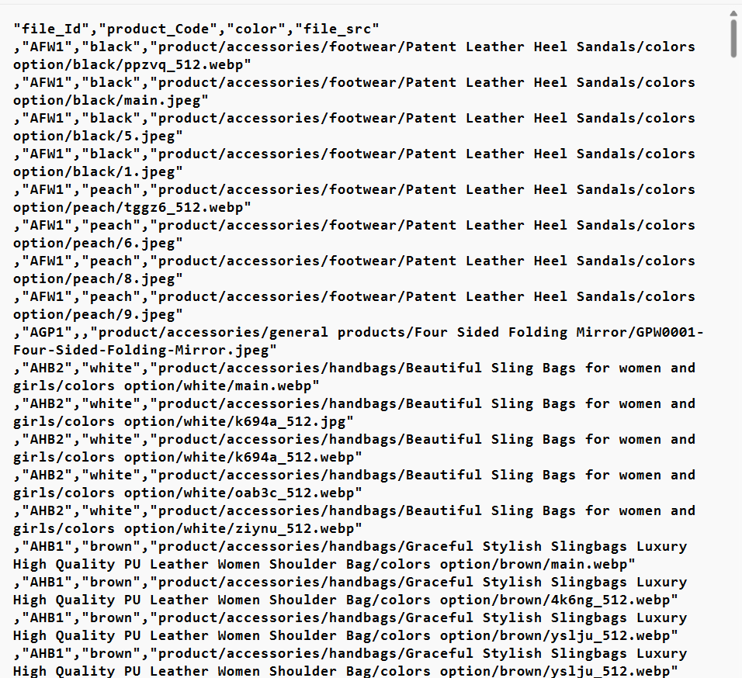

mysql> SELECT VERSION();
+-----------+
| VERSION() |
+-----------+
| 5.7.13 |
+-----------+
1 row in set (0,00 sec)

mysql>
+---------------------------+
| @@GLOBAL.secure_file_priv |
+---------------------------+
| NULL |
+---------------------------+
1 row in set (0,00 sec)

-- USE ...

mysql> LOAD DATA INFILE '/var/lib/mysql-files/myfile.csv'
-> INTO TABLE `test_files`
-> COLUMNS TERMINATED BY ',' ENCLOSED BY '\"'
-> LINES TERMINATED BY '\n';
ERROR 1290 (HY000): The MySQL server is running with the --secure-file-priv
option so it cannot execute this statement

to disable secure-file-prive at time of infile after getting proper csv

edit the file /etc/mysql/mysql.conf.d/mysqld.cnf and add the following line at the end:
secure_file_priv=""
Then make sure to restart the service.
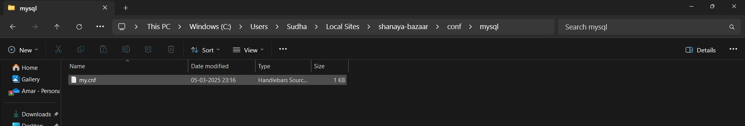

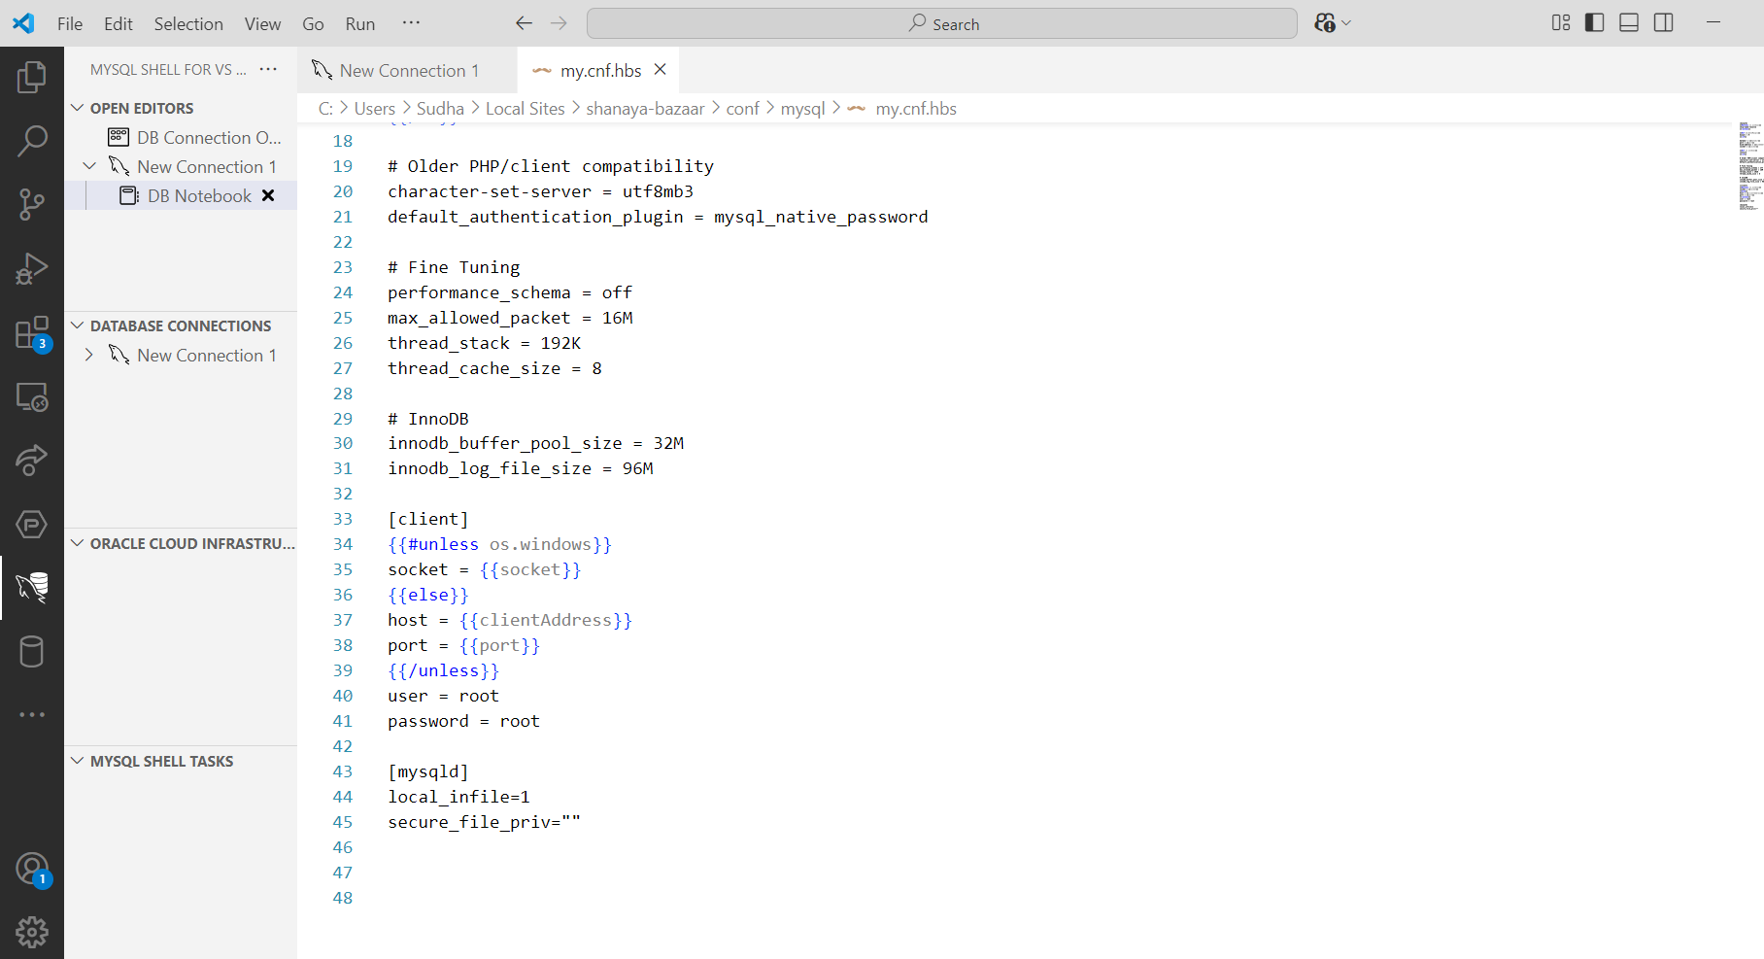

we needed to add at 45 line this and then restart thr mysql , use infile again

mysql> LOAD DATA LOCAL INFILE 'C:/Sudhadocuments/Shanaya_bazaar/classic_models_dataset/filesImagesVideo.csv' INTO TABLE product_files FIELDS TERMINATED BY ',' ENCLOSED BY '"' LINES TERMINATED BY '\n' IGNORE 1 ROWS;
Query OK, 145 rows affected, 292 warnings (0.04 sec)
Records: 145 Deleted: 0 Skipped: 0 Warnings: 292

We tried again as it causes error.

mysql> LOAD DATA LOCAL INFILE 'C:/Sudhadocuments/Shanaya_bazaar/classic_models_dataset/filesImagesVideo.csv' INTO TABLE product_files FIELDS TERMINATED BY ',' ENCLOSED BY '"' LINES TERMINATED BY '\n' IGNORE 1 ROWS;
Query OK, 145 rows affected, 292 warnings (0.01 sec)
Records: 145 Deleted: 0 Skipped: 0 Warnings: 292

mysql> select * from product_files limit 1;
+---------+--------------+-------+------------------------------------------------------------------------------------------------------+
| file_Id | product_Code | color | file_src
|
+---------+--------------+-------+------------------------------------------------------------------------------------------------------+
| 767 | AFW1 | black | product/accessories/footwear/Patent Leather Heel Sandals/colors option/black/ppzvq_512.webp"
,"AFW1 |
+---------+--------------+-------+------------------------------------------------------------------------------------------------------+
1 row in set (0.00 sec)
select * from product_files limit 1;
+---------+--------------+-------+------------------------------------------------------------------------------------------------------+
| file_Id | product_Code | color | file_src |
+---------+--------------+-------+------------------------------------------------------------------------------------------------------+
| 767 | AFW1 | black | product/accessories/footwear/Patent Leather Heel Sandals/colors option/black/ppzvq_512.webp"
,"AFW1 |
+---------+--------------+-------+------------------------------------------------------------------------------------------------------+
1 row in set (0.00 sec)

mysql> select * from product_files limit 1;
+---------+--------------+-------+------------------------------------------------------------------------------------------------------+
| file_Id | product_Code | color | file_src |
+---------+--------------+-------+------------------------------------------------------------------------------------------------------+
| 767 | AFW1 | black | product/accessories/footwear/Patent Leather Heel Sandals/colors option/black/ppzvq_512.webp"
,"AFW1 |
+---------+--------------+-------+------------------------------------------------------------------------------------------------------+
1 row in set (0.00 sec)

mysql> delete from product_files;
Query OK, 145 rows affected (0.01 sec)

mysql> LOAD DATA LOCAL INFILE 'C:/Sudhadocuments/Shanaya_bazaar/classic_models_dataset/filesImagesVideo.csv' INTO TABLE product_files FIELDS TERMINATED BY ',' ENCLOSED BY '"' LINES TERMINATED BY '\n' IGNORE 1 ROWS (product_Code, color, file_src);
Query OK, 289 rows affected, 290 warnings (0.01 sec)
Records: 289 Deleted: 0 Skipped: 0 Warnings: 290

mysql> select * from product_files limit 1;
+---------+--------------+-------+----------+
| file_Id | product_Code | color | file_src |
+---------+--------------+-------+----------+
| 1022 | | AFW1 | black |
+---------+--------------+-------+----------+
1 row in set (0.00 sec)

mysql> delete from product_files;
Query OK, 289 rows affected (0.01 sec)

mysql> LOAD DATA LOCAL INFILE 'C:/Sudhadocuments/Shanaya_bazaar/classic_models_dataset/filesImagesVideo.csv' INTO TABLE product_files FIELDS TERMINATED BY ',' ENCLOSED BY '"' LINES TERMINATED BY '\n' IGNORE 1 ROWS (file_Id,product_Code, color, file_src);
Query OK, 145 rows affected, 292 warnings (0.01 sec)
Records: 145 Deleted: 0 Skipped: 0 Warnings: 292

mysql> select * from product_files limit 1;
+---------+--------------+-------+------------------------------------------------------------------------------------------------------+
| file_Id | product_Code | color | file_src
|
+---------+--------------+-------+------------------------------------------------------------------------------------------------------+
| 1533 | AFW1 | black | product/accessories/footwear/Patent Leather Heel Sandals/colors option/black/ppzvq_512.webp"
,"AFW1 |
+---------+--------------+-------+------------------------------------------------------------------------------------------------------+
1 row in set (0.00 sec)
delete from product_files;
Query OK, 145 rows affected (0.00 sec)

When we changed our csv file like this

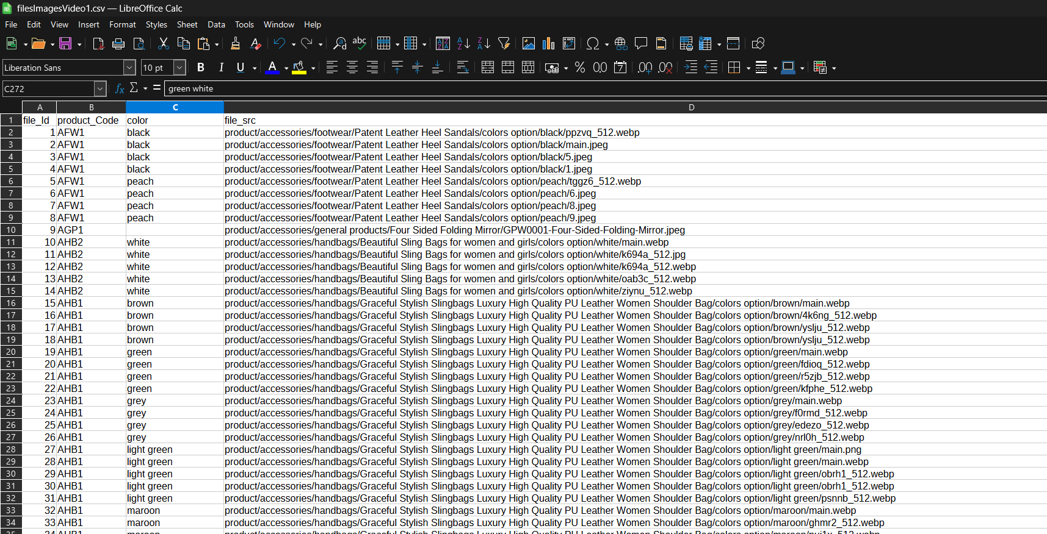

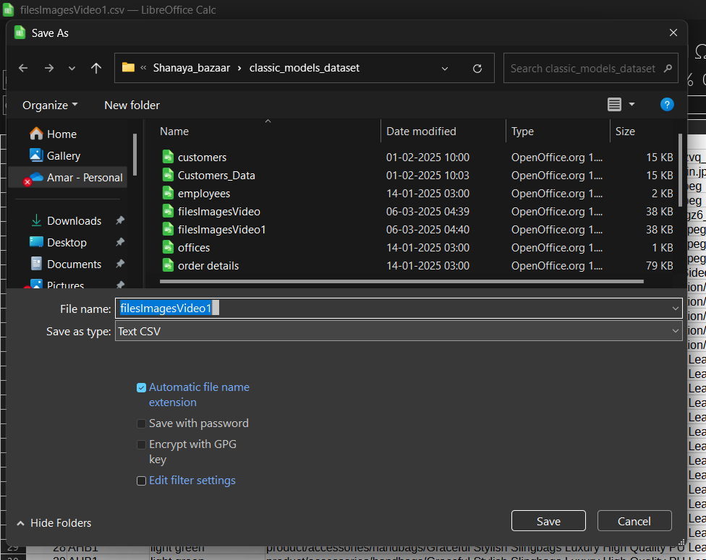

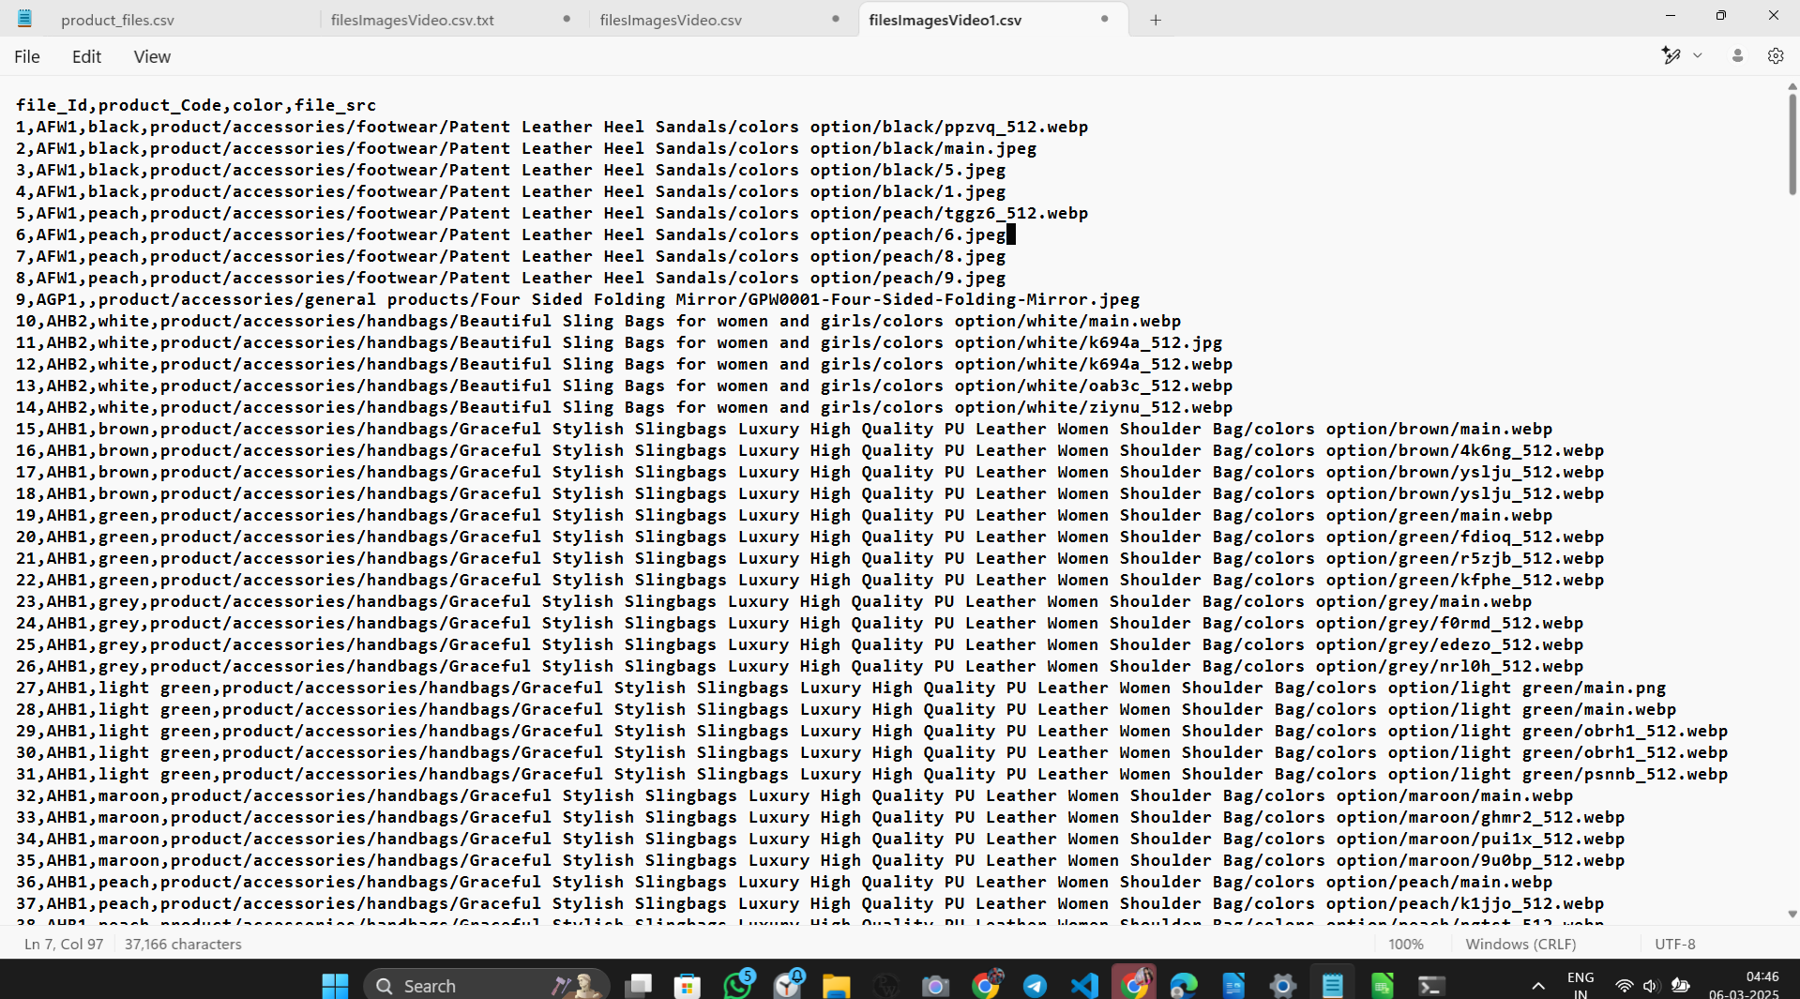

earlier , at start created problem.

mysql> LOAD DATA LOCAL INFILE 'C:/Sudhadocuments/Shanaya_bazaar/classic_models_dataset/filesImagesVideo1.csv' INTO TABLE product_files FIELDS TERMINATED BY ',' ENCLOSED BY '"' LINES TERMINATED BY '\n' IGNORE 1 ROWS;
Query OK, 288 rows affected, 288 warnings (0.02 sec)
Records: 288 Deleted: 0 Skipped: 0 Warnings: 288

mysql> select * from product_files limit 1;
+---------+--------------+-------+---------------------------------------------------------------------------------------------+
| file_Id | product_Code | color | file_src |
+---------+--------------+-------+---------------------------------------------------------------------------------------------+
| 1 | AFW1 | black | product/accessories/footwear/Patent Leather Heel Sandals/colors option/black/ppzvq_512.webp |
+---------+--------------+-------+---------------------------------------------------------------------------------------------+
1 row in set (0.00 sec)

mysql

